

ASSET VERIFICATION AND RECORDING TOOL KIT


Plot 31, Bukoto Street
P.O Box 7657, Kampala, Uganda
+256 (0) 39 2000216/0772525235
email: cpa@cpa.ug

www.cpa.com

August to September 2026

VERIFICATION DETAILS

NAME OF THE REGION: | NORTHERN REGION
SUB-REGION: | LANGO SUB REGION
Name of Local Government | DOKOLO DISTRICT LOCAL GOVERNMENT
VERIFIER PARTICULARS
Full name | AGANYO MERCY
Contact/ email and Telephone | 0786551826
Supervisor/ Sub team leader
Name | MR. DENIS
Contact | 0779622063
Date of submission | 31ST AUGUST 2026s

HEALTH CENTRES
INFORMANT INTERVIEW/DISCUSSION GUIDE (INCHARGE OR RESPONSIBLE PERSON)

Name of Health Centre: ABALANG HEALTH CENTER III

1a | Does the Facility have a record of all assets provided under UgIFT.  (Obtain a record and verify if it has the costs and numbers supplied | YES
1b | If Not ask how many were supplied and when.

2 | How does this facility Maintain (repair/service/replace) the assets provided under Ugift

In case of any damages, Abalang Health Center III uses 10% of Primary Health Care funds to repair and service the damages.

3 | Does the facility take regular record about functionality/ or breakdown of the assets provided?

Yes, the facility always takes regular records about the functionality of the assets provided and any breakdown is recorded for decision making.

4 | How has the UgIFT support helped in service delivery in the area, any issues, challenges and any recommendations for better program implementation.

The UGIFT support has improved safe delivery of mothers in the community and it has as well improved on diagnosis and care of patients through the equipment provided.

Challenges: The infrastructure does not accommodate staff on night shift
It is hard to get the strips of the equipment provided in the market like the strips for the microscope.

Recommendation: UGIFT should provide equipment that are current in the market
MCH should be provided with a strong solar system

PROCEED TO VERIFICATION AFTER THIS DISCUSSION

Health centre checklist

NAME OF LG: DOKOLO DISTRICT LOCAL GOVERNMENT NAME OF HEALTH FACILITY: ABALANG HEALTH CENTER III

Equipment/ Item | Department | Asset Number | Item  Description | Life in Months | Tag Number ( engrave no.) | Date Of Purchase | Date Placed In Service | Recoverable cost | Cost | Acc Dep Cost | Net Book Value | Ytd Deprn | Equipment status | Remarks
B.P. Machine, Digital(2) | OPD  MCH |  | Digital | 60 | Not engraved | October 2021 | February 2022 |  |  |  |  |  | Functional | Good working condition
B.P. Machine (Aneroid wall mounted) (2) | MCH |  | Manual | 60 |  | October 2021 | February 2022 |  |  |  |  |  | Functional | Good condition but 1 is still in the store
Autoclave 20 Liters.,Duo Operated (2) | MCH |  | Metallic | 60 |  | October 2021 | February 2022 |  |  |  |  |  | Functional | Good condition
Bowl, Kick (1) | Store |  | Metallic | 60 |  | October 2021 | February 2022 |  |  |  |  |  | Non Functional | It got spoilt because it was sub standard
Bowl Stand (3) | MCH  IPD |  | Metallic | 70 | Not engraved | October 2021 | February 2022 |  |  |  |  |  | Functional | Good condition
Counting chamber Neubauer- Improved (2) | OPD |  | Plastic | 60 | Not engraved | October 2021 | February 2022 |  |  |  |  |  | Functional | Good condition and 1 is still in store
Cupboard Steel, Lockable (6) | MCH  OPD |  | Metallic | 90 | Not engraved | October 2021 | February 2022 |  |  |  |  |  | Functional | Good condition
Drip Stand (9) | MCH  IPD |  | Metallic | 70 | Not engraved | October 2021 | February 2022 |  |  |  |  |  | Functional | Good condition and 4 are still in the store
ESR Stand (1) | Store |  | Glass in nature | 36 | Not engraved | October 2021 | February 2022 |  |  |  |  |  | Non-Functional | Still in store
Examination Couch (4) | MCH |  | Metallic with mattress | 70 | Not engraved | October 2021 | February 2022 |  |  |  |  |  | Functional | Good condition
Examination light,LED (3) | MCH  IPD |  | Plastic | 50 | Not engraved | October 2021 | February 2022 |  |  |  |  |  | Functional | Good condition but two are still in store
Glucometer (2) | Store |  | Manual and plastic | 60 | Not engraved | October 2021 | February 2022 |  |  |  |  |  | Non -Functional | Still kept in the stores
Haemoglobin Meter, Digital (2) | Store |  | Digital | 60 | Not engraved | October 2021 | February 2022 | - | - | - | - |  | Non-functional | There are no strips that match it
Height Meter (2) | MCH  OPD |  | Metallic | 60 | Not engraved | October 2021 | February 2022 |  |  |  |  |  | Functional | Good condition
Instrument Trolley (4) | MCH |  | Metallic | 60 | Not engraved | October 2021 | February 2022 |  |  |  |  |  | Functional | Good condition
Microscope Binocular (1) | Store |  | Metallic | 50 | Not engraved | October 2021 | February 2022 |  |  |  |  |  | Non-functional | The  lenses are not okay, it does not see parasites
Otoscope (1) | OPD |  | Manual | 60 | Not engraved | October 2021 | February 2022 |  |  |  |  |  | Functional | Good condition
Patient Screen (5) | OPD |  | Digital and plastic | 50 | Not engraved | October 2021 | February 2022 |  |  |  |  |  | Functional | Two are spoilt
Patient Trolley (1) | OPD  MCH |  | Metallic | 60 | Not engraved | October 2021 | February 2022 |  |  |  |  |  | Functional | Good condition
Refrigerator, Basic (2) | Store |  | Metallic | 60 | Not engraved | October 2021 | - |  |  |  |  |  | Non-Functional | It is old model
Stethoscope (8) | MCH  OPD |  | Manual | 50 | Not engraved | October 2021 | February 2022 |  |  |  |  |  | Functional | Good condition and two are spoilt
Stop Watch (1) | Store |  | Metallic | 50 | Not engraved | October 2021 | February 2022 |  |  |  |  |  | Non-functional | It got spoilt
Stretcher (2) | MCH |  | Metallic with leather | 60 | Not engraved | October 2021 | February 2022 |  |  |  |  |  | Functional | Good condition
Stove, Gas (2) | MCH |  | Metallic | 60 | Not engraved | October 2021 | February 2022 |  |  |  |  |  | Functional | Good condition
Weighing Scale with Height Meter, Adult (2) | Store |  | Metallic | 50 | Not engraved | October 2021 | February 2022 |  |  |  |  |  | Non-Functional | Got spoilt because it was weak
Weighing Scale, Infant (2) | MCH |  | Plastic | 60 | Not engraved | October 2021 | February 2022 |  |  |  |  |  | Functional | Good condition and 1 is spoilt
Weighing Scale, Toddler (1) | MCH |  | Plastic | 70 | Not engraved | October 2021 | February 2022 |  |  |  |  |  | Functional | Good condition
Wheel Chair (4) | MCH  OPD |  | Metallic with leather | 70 | Not engraved | October 2021 | February 2022 |  |  |  |  |  | Functional | Good condition but 2 are still in the store
Audio Visual Equipment (1) | Store |  | Manual | 40 | Not engraved | October 2021 | February 2022 |  |  |  |  |  | Non - Functional | Kept in the store because there is no power
Medical Waste Bin (20) | MCH  OPD  LAB |  | Plastic | 60 | Not engraved | October 2021 | February 2022 |  |  |  |  |  | Functional | Good condition but 9 are broken
Wall Clock (4) | MCH  OPD |  | Metallic | 24 | Not engraved | October 2021 | February 2022 |  |  |  |  |  | Functional | Good condition
Diagnostic Equipment Set for MCH (3) | MCH |  | Metallic | 60 | Not engraved | October 2021 | February 2022 |  |  |  |  |  | Functional | 1 is working and 2 are still in store
Diagnostic Equipment Set for OPD (2) | OPD |  | Metallic | 60 | Not engraved | October 2021 | February 2022 |  |  |  |  |  | Functional | 1 is working and 1 is still in the store
Glassware Set, Laboratory, Basic (2) | LAB |  | Glass in nature | 36 | Not engraved | October 2021 | February 2022 |  |  |  |  |  | Functional | Good working condition
Hollow Ware Set, Treatment (2) | Store |  | Metallic | 60 | Not engraved | October 2021 | - |  |  |  |  |  | Non – Functional | Kept in the store
Instrument Set, Dressing (7) | MCH  OPD |  | Metallic | 60 |  | October 2021 | February 2022 |  |  |  |  |  | Functional | Good condition and two are still in the store
Instrument Set, Basic ENT (1) | MCH  IPD |  | Stainless steel | 60 | Not engraved | October 2021 | February 2022 |  |  |  |  |  | Functional | Good condition
Instrument Set, Suture (3) | MCH |  | Stainless steel | 70 | Not engraved | October 2021 | February 2022 |  |  |  |  |  | Functional | Good condition and 2 are still in the store
Pulse Oximeter, Hand held (2) | Store |  | Manual | 60 | Not engraved | October 2021 | February 2022 |  |  |  |  |  | Non – Functional | Still in the store
Bed, Adult Patient with Mattress (10) | MCH |  | Metallic with mattress | 90 | Not engraved | October 2021 | February 2022 |  |  |  |  |  | Functional | Good condition
Bed, Pediatric Patient, With Mattress (4) | IPD |  | Metallic with mattress | 90 | Not engraved | October 2021 | February 2022 |  |  |  |  |  | Functional | Good condition
Bedside Locker (10) | MCH  IPD |  | Metallic | 90 | Not engraved | October 2021 | February 2022 |  |  |  |  |  | Functional | Good condition
Cupboard, Instrument (1) | MCH |  | Metallic | 70 | Not engraved | 0ctober 2021 | February 2022 |  |  |  |  |  | Functional | Good condition
Delivery Bed, Hydraulic Manual (1) | Store |  | Metallic with mattress | 90 | Not engraved | October 2021 | February 2022 |  |  |  |  |  | Non - Functional | It got spoilt
Oxygen Therapy Apparatus, Mininum 45L cylinder (2) | MCH |  | Metallic | 70 | Not engraved | October 2021 | February 2022 |  |  |  |  |  | Functional | Good condition but 1 is spoilt
Resuscitator Manual, Infant, with all Mask sizes (1) | MCH |  | Plastic | 60 | Not engraved | October 2021 | February 2022 |  |  |  |  |  | Functional | Good condition
Resuscitator Manual, Adult, with all mask sizes (1) | MCH |  | Plastic | 60 | Not engraved | October 2021 | February 2022 |  |  |  |  |  | Functional | Good condition
Suction Apparatus, (Electric) 1 | Store |  | Electrical | 50 | Not engraved | October 2021 | February 2022 |  |  |  |  |  | Non – Functional | Still in the store
Nebulizer, Ultrasonic (1) | MCH |  | Electrical | 50 | Not engraved | October 2021 | February 2022 |  |  |  |  |  | Functional | Good condition
Oxygen Concentrator, Duo Flow (1) | MCH |  | Electrical | 60 | Not engraved | October 2021 | February 2022 |  |  |  |  |  | Functional | Good condition
Bench (4) | OPD  LAB  MCH |  | Wooden | 90 | Not engraved | October 2021 | February 2022 |  |  |  |  |  | Functional | Good condition
Disinfection Buckets (2) | MCH |  | Metallic | 90 | Not engraved | October 2021 | February 2022 |  |  |  |  |  | Functional | Good condition but 1 is spoilt
Baby Cot (2) | MCH  ANC |  | Plastic | 60 | Not engraved | October 2021 | February 2022 |  |  |  |  |  | Functional | Good condition
Diagnostic Equipment Set for Ward (2) | IPD |  | Stainless steel | 70 | Not engraved | October 2021 | February 2022 |  |  |  |  |  | Functional | Good condition and 1 is still in the store
Hollow Ware Set, Ward (2) | Store |  | stainless steel | 70 | Not engraved | October 2021 | - |  |  |  |  |  | Non – Functional | Kept in the store
Instrument Set, Delivery (5) | MCH |  | Metallic | 60 | Not engraved | October 2021 | February 2022 |  |  |  |  |  | Functional | Good condition
Instrument Set, Stitch Removing (5) | IPD  MCH |  | Metallic | 90 | Not engraved | October 2021 | February 2022 |  |  |  |  |  | Functional | Good condition 3 are still in the store
MVA Kit (5) | Health |  | Plastic | 70 | Not engraved | October 2021 | February 2022 |  |  |  |  |  | non- Functional | All are spoilt
Stool, Laboratory (3) | LAB |  | Metallic with leather | 90 | Not engraved | October 2021 | February 2022 |  |  |  |  |  | Functional | Good condition
Penguin Sucker (3) | MCH |  | Rubber | 50 | Not engraved | October 2021 | February 2022 |  |  |  |  |  | Functional | Good condition
Fetoscope, Dopplar (2) | MCH |  | Plastic | 70 | Not engraved | October 2021 | February 2022 |  |  |  |  |  | Functional | Good condition
Bubble CPAP | - | - | - | -- | - | - | - | - | - | - | - | - | - | -
Centrifuge (Electric) (1) | LAB |  | Electrical | 50 | Not engraved | October 2021 | February 2022 |  |  |  |  |  | Functional | Good condition
Kangaroo Mother Care Chair (1) | Store |  | Metallic with leather | 70 | Not engraved | October 2021 | February 2022 |  |  |  |  |  | Non – Functional | Spoilt
Radiant Infant Warmer | - | - | - | - | - | - | - | - | - | - | - | - | - | -
Haemoglobin Meter, Sahli (2) | Store |  | Manual | 80 | Not engraved | October 2021 | february2022 |  |  |  |  |  | Non – Functional | Out dated
Delivery Bed | - | - | - | - | - | - | - | - | - | - | - | - | - | -
Examination light | - | - | - | - | - | - | - | - | - | - | - | - | - | -
Instrument set, ENT Basic for HCIII | - | - | - | - | - | - | - | - | - | -- | - | - | - | -
Bag Valve mask (Ambu Bag), Neonatal (15) | MCH |  | Rubber | 40 | Not engraved | October 2021 | February 2022 |  |  |  |  |  | Functional | Good condition
Incubator | - | - | - | - | - | - | - | - | - | - | - | - | - | -
Office Chair (7) | OPD  MCH  IPD |  | Metallic with leather | 90 | Not engraved | October 2021 | February 2022 |  |  |  |  |  | Functional | Good condition but 4 are spoilt
Desk (5) | MCH  OPD |  | Wooden | 90 | Not engraved | October 2021 | February 2022 |  |  |  |  |  | Functional | Good condition
Filing Cabinet (2) | MCH  OPD |  | Metallic | 90 | Not engraved | October 2021 | February 2022 |  |  |  |  |  | Functional | Good condition
Non -Residential Buildings (2) | Health |  | Concrete building | 300 | Not engraved | October 2021 | February 2022 |  |  |  |  |  | Functional | Good state
Residential Buildings (2)  1 Twin house and  MCH Block | Health |  | Block building | 600 | Not engraved | October 2021 | February 2022 |  |  |  |  |  | Functional | Good state

SAMPLE PICTURES OF ABALANG HEALTH CENTRE III
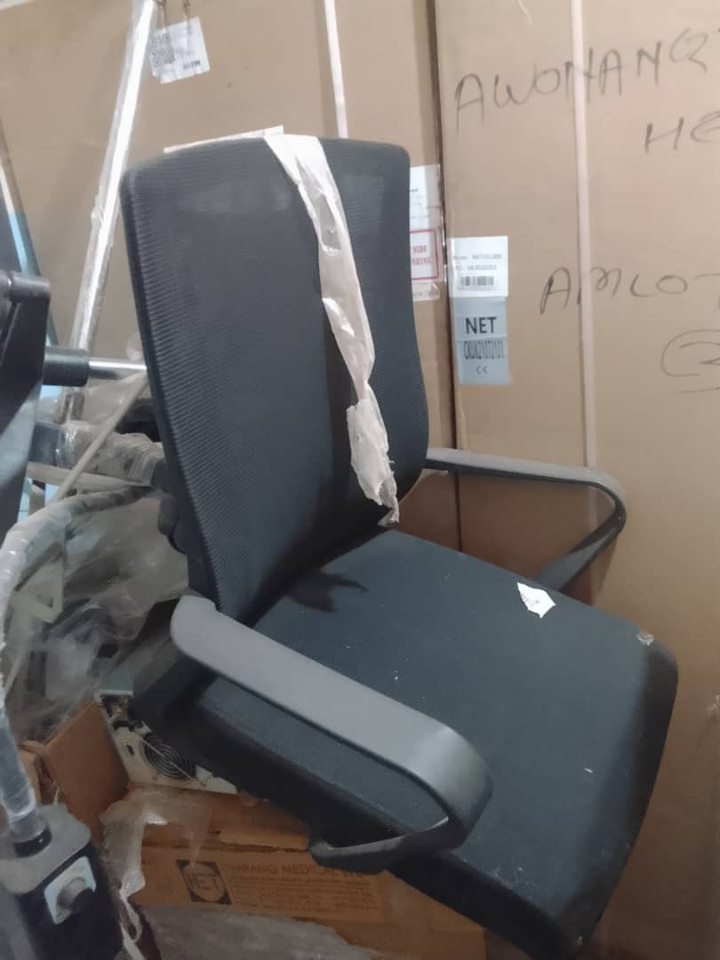

Sample of a broken Chair
and other
Equipment in the Store

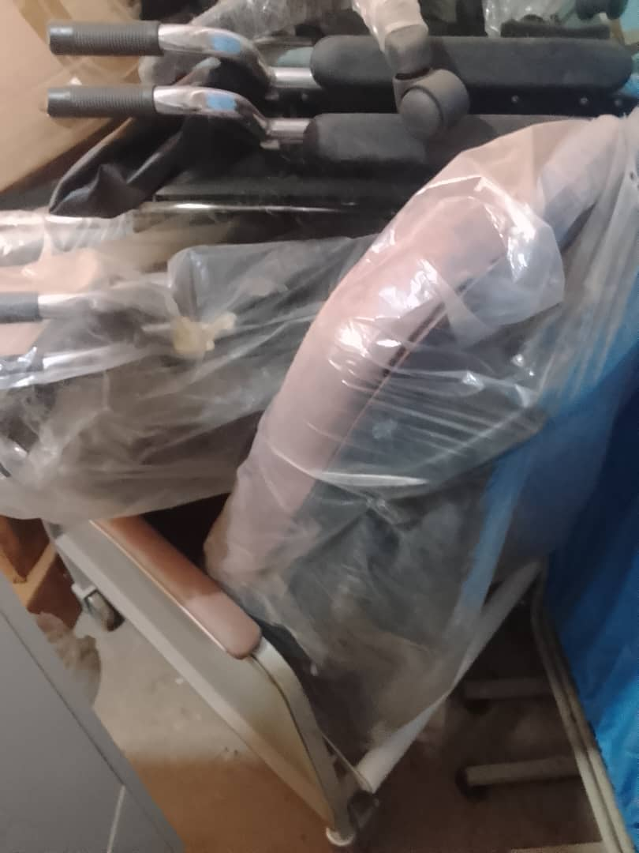

Other Equipment in the Store

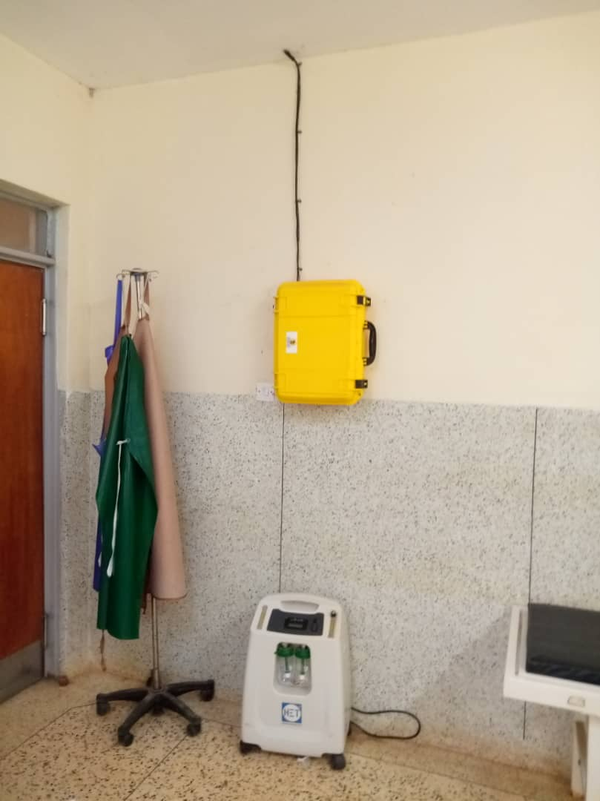

Oxygen Concentrator
Dual Flow

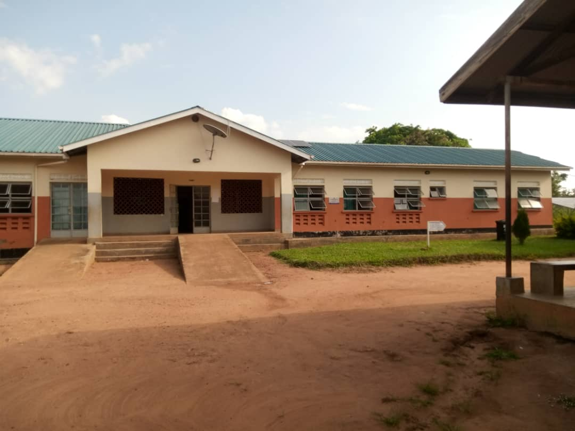

MCH Ward

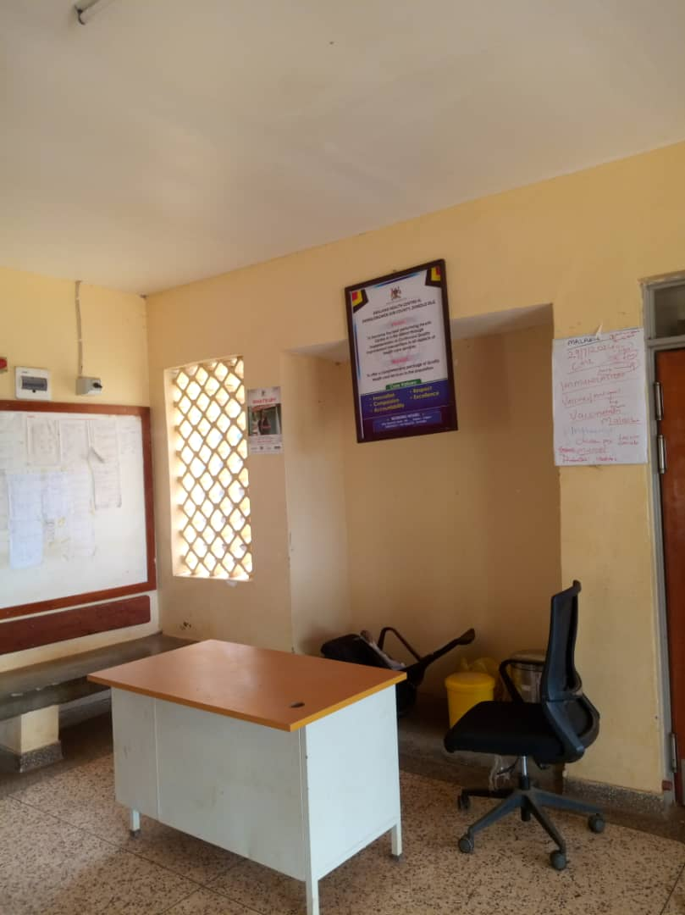

Office Chair and Desk

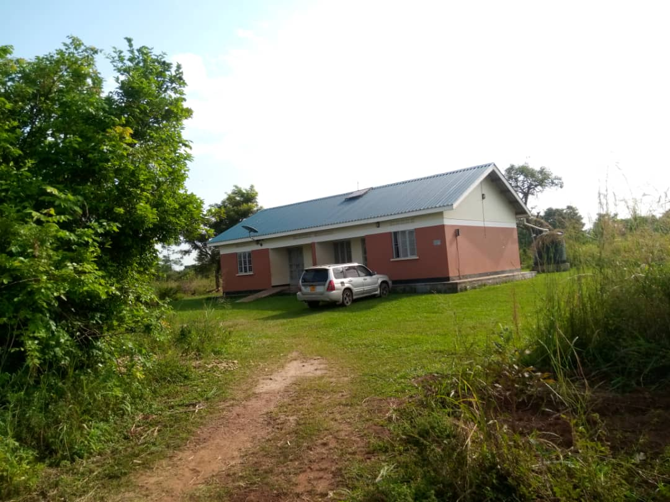

Sample of Twin
Staff House

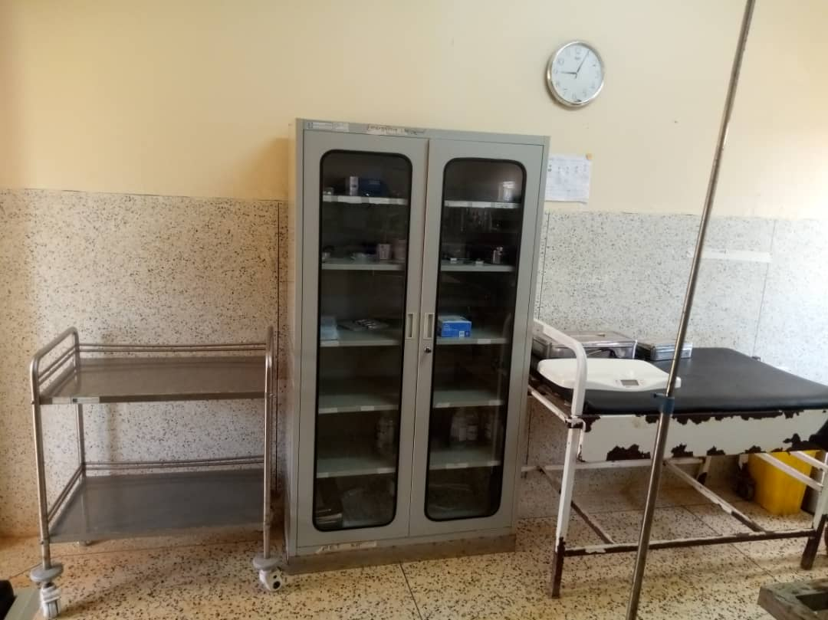

Instrument Trolley,
Wall Clock, Cupboard
Steel Lockable
and
Weighing Scale Infant

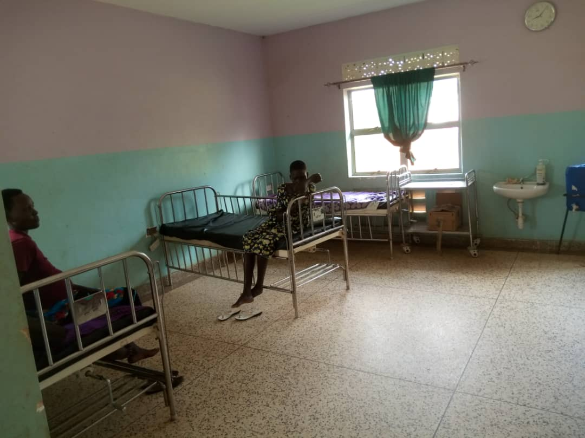

Patient Bed Adult
with Mattress

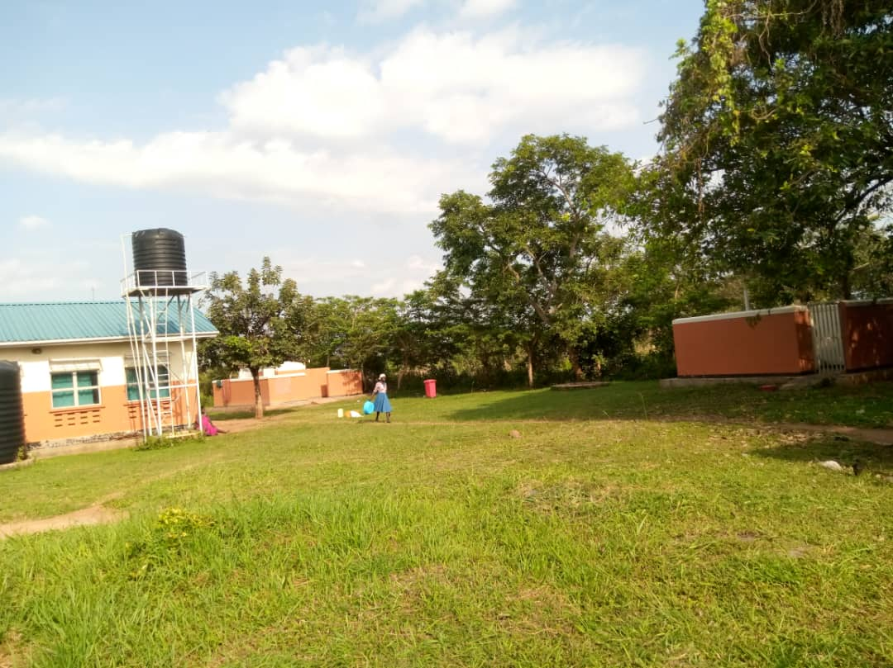

Water Tanks
and
Pit Latrines

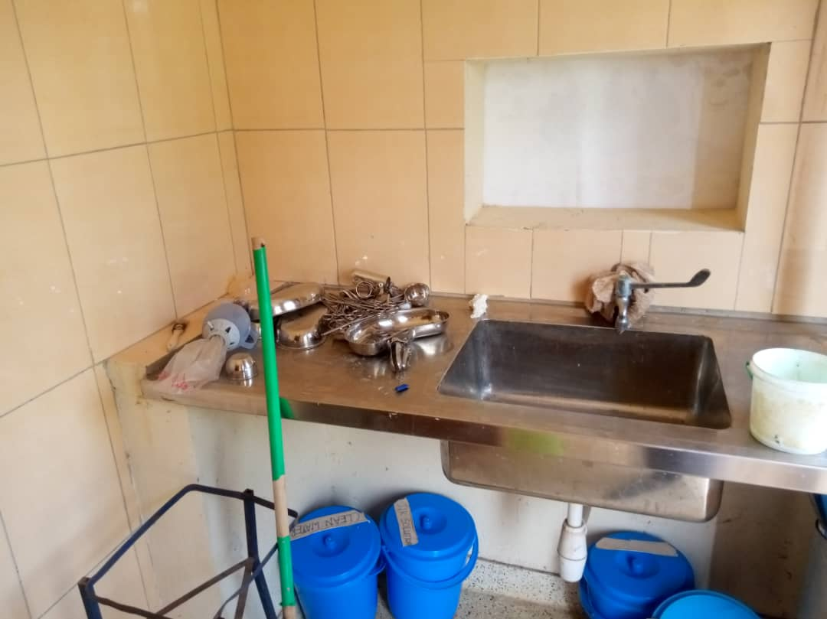

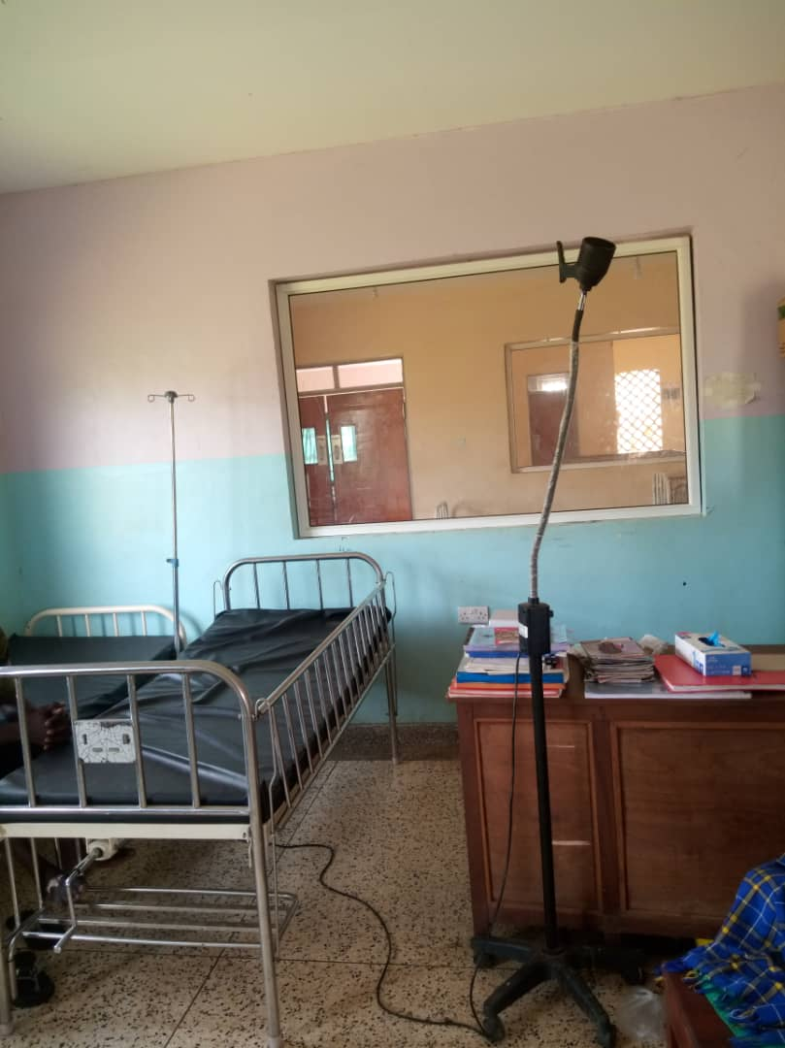

Examination Light LED

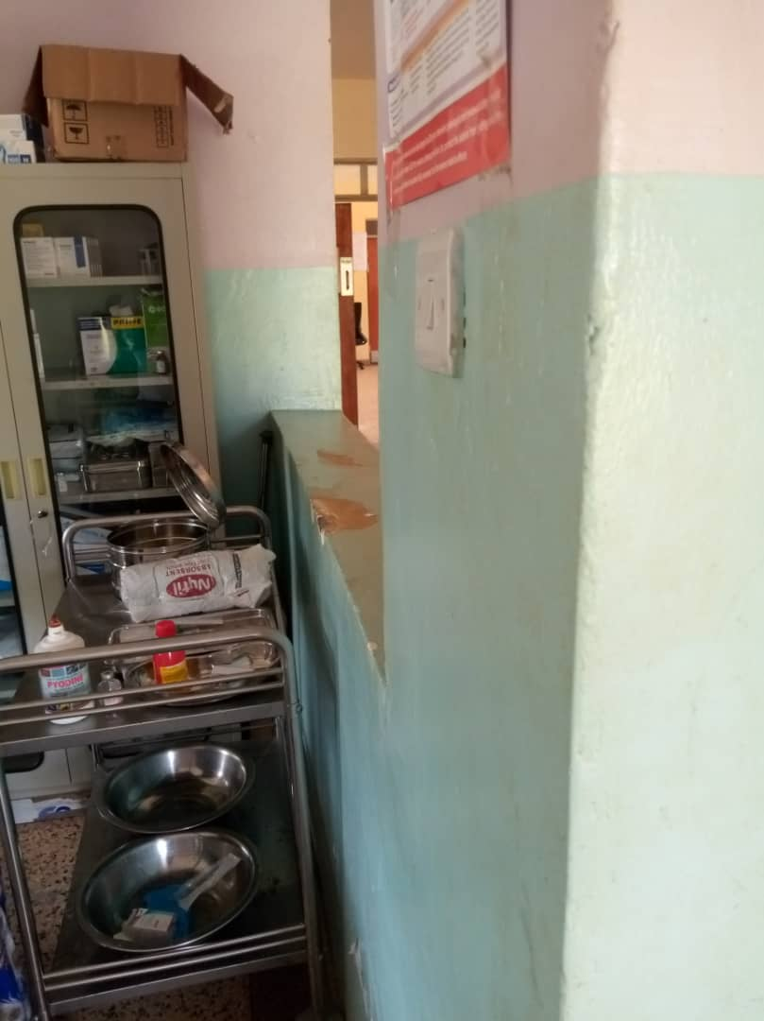

Cupboard Steel Lockable
and
other Equipment

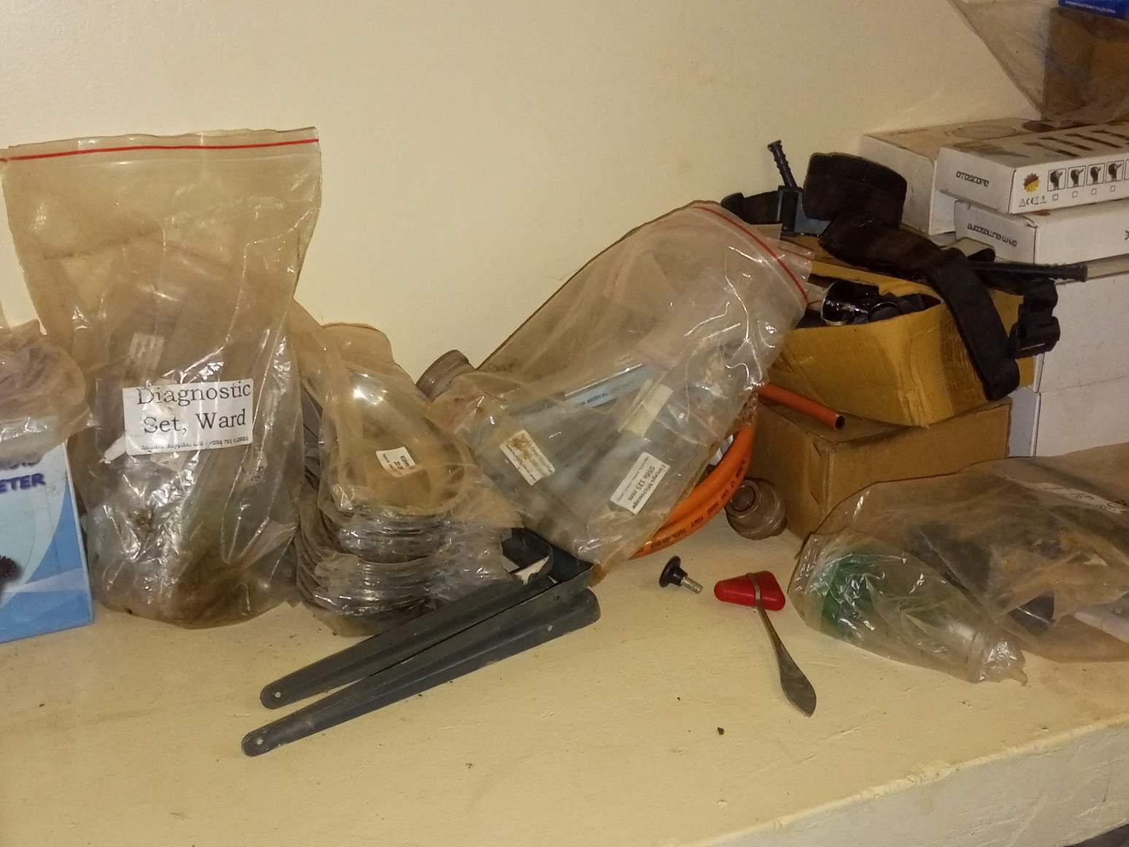

Equipment in the Store

SCHOOL VERIFICATION CHECKLIST

SCHOOL INTERVIEW/DISCUSSION GUIDE

Name of school: ADEKNINO SEED SECONDARY SCHOOL

1a | Does the Facility have a record of all assets provided under UgIFT.  (Obtain a record and verify if it has the costs and numbers supplied | YES
1b | If Not ask how many were supplied and when.

2 | How does this facility Maintain (repair/service/replace) the assets provided under Ugift

The school uses the PTA and Universal Secondary Education funds
(USE) to service and repair the spoilt equipment.

3 | Does the facility take regular record about functionality/ or breakdown of the assets provided?  Nonfunctional/ working, and reasons for non-functionality.

Yes, the school always conducts regular monitoring on the equipment provided in order to record their functionality

4 | How has the UgIFT support helped in service delivery in the area, any issues, challenges and any recommendations for better program implementation.

The UGIFT support has improved the enrolment of students that is from 100 students to 280 students.

Challenges: There are no apparatus in the laboratory
Some of the equipment are weak.

Recommendations: UGIFT should provide the computers that were not given to the school and also stock chemicals in the lab

PROCEED TO VERIFICATION AFTER THIS DISCUSSION

SCHOOL FURNITURE
(School Desks, Office chairs, Laboratory stools, Book shelves)

Name of LG: DOKOLO DISTRICT LOCAL GOVERNMENT Name of SCHOOL: ADEKNINO SEED SECONDARY SCHOOL

Equipment/ Item | Department | Asset Number | Item  Description | Life in Months | Tag Number ( engrave no.) | Date Of Pur | Date Placed In Service | Recoverable cost |  | Cost | Acc Dep Cost | Net Book Value | Ytd Deprn | Equipment status | Remarks
School Desks(122 | Education |  | Wooden with metallic stands | 90 | ADEKNINO/DK/  001-122 | Jan 2025 | February 2025 |  |  |  |  |  |  | Functional | Good condition and 3 are broken
Office chairs(4) | Education |  | Metallic with cushion | 90 | ADEKNINO/CH/  001-004 | January 2025 | February 2025 |  |  |  |  |  |  | Functional | Good conditio9n
Laboratory stools(122) | Education |  | Wooden | 90 | ADEKNINO SSS/  ST/001-122 | January 2025 | February 2025 |  |  |  |  |  |  | Functional | Good condition
Bookshelves (15) | Education |  | Metallic | 120 |  | January 2025 | February 2025 |  |  |  |  |  |  | Functional | Good condition

ICT ITEMS TO VERIFY
(Desktop Computer, Server Processor, Network Switch 24 Port, Multipurpose Printer, UPS, Projector, Air Conditioners, Server, CCTV Camera)

Name of LG: DOKOLO DISTRICT LOCAL GOVERNMENT Name of SCHOOL: ADEKNINO SEED SECONDARY SCHOOL

Equipment/ Item | Department | Asset Number | Item  Description | Life in Months | Tag Number ( engrave no.) | Date Of Pur | Date Placed In Service | Recoverable cost | Cost | Acc Dep Cost | Net Book Value | Ytd Deprn | Equipment status | Remarks
Desktop computers | - | - | - | - | - | - | - | - | - | - | - | - | - | -
Server processor (1) | Education |  | Digital | 60 |  | January 2025 | February 2025 |  |  |  |  |  | Functional | Good function
Network swich port. (1) | Education |  | Digital | 60 |  | January 2025 | February 2025 |  |  |  |  |  | Functional | Good condition
Multi-purpose printer | - | - | - | - | - | - | - | - | - | - | - | - | - | -
Projector. (1) | Education |  | Digital | 70 |  | January 2025 | February 2025 |  |  |  |  |  | Functional | Good condition
Air conditioners | - | - | - | - | - | - | - | - | - | - | - | - | - | --
Server (1) | Education |  | Digital | 60 |  | January 2025 | February 2025 |  |  |  |  |  | Functional | Good condition
CCTV Camera.  2. | Education |  | Digital | 60 |  | January 2025 | February 2025 |  |  |  |  |  | Functional | Good condition

BUILDINGS TO VERIFY
(Non- Residential and Residential, Kitchen, Toilets/Pit latrine Water tanks, Fences etc.)

Name of LG: DOKOLO DISTRICT LOCAL GOVERNMENT Name of SCHOOL: ADEKNINO SEED SECONDARY SCHOOL

Equipment/ Item | Department | Asset Number | Item  Description | Life in Months | Tag Number ( engrave no.) | Date Of Pur | Date Placed In Service | Recoverable cost | Cost | Acc Dep Cost | Net Book Value | Ytd Deprn | Equipment status | Remarks
Non-Residential buildings
Laboratory.  I BLOCK | Education |  | Concrete block building | 600 |  | January 2025 | February 2025 |  |  |  |  |  | Functional | Good state
Library and multi-purpose hall.  1 BLOCK | Education |  | Concrete block building | 600 |  | January 2025 | February 2025 |  |  |  |  |  | Functional | Good state
Residential buildings
Staff houses.  TWO BLOCKS OF TWO | Education |  | Concrete twin building | 600 |  | January 2025 | February 2025 |  |  |  |  |  | Functional | It’s in a good state
Pit latrines (4) Four stance | Education |  | Concrete building | 300 |  | January 2025 | February 2025 |  |  |  |  |  | Functional | They are in a good state
Water tanks.  one | Education |  | Concrete building | 300 |  | January 2025 | February 2025 |  |  |  |  |  | Functional | Good condition
Fence | - | - | - | - | - | - | - | - | - | - | - | - | - | The school is not fenced

SAMPLE PICTURES OF ADEKNINO SEED SECONDARY SCHOOL

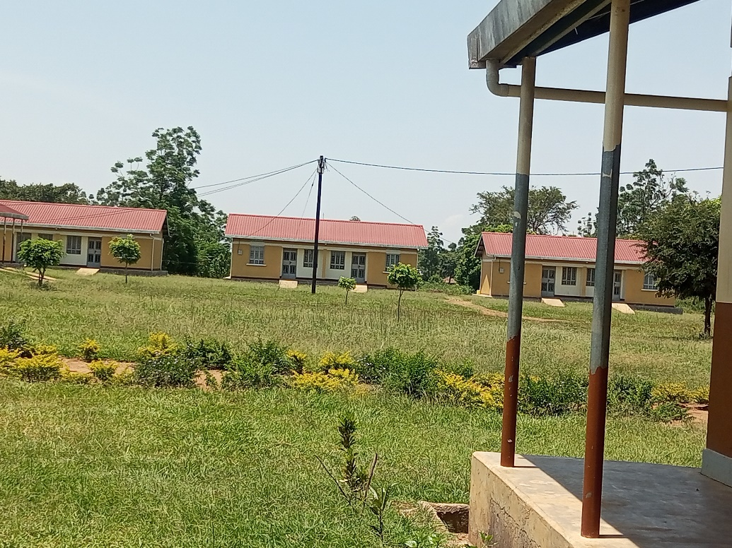

Staff Quarters in Adeknino
Seed Secondary School

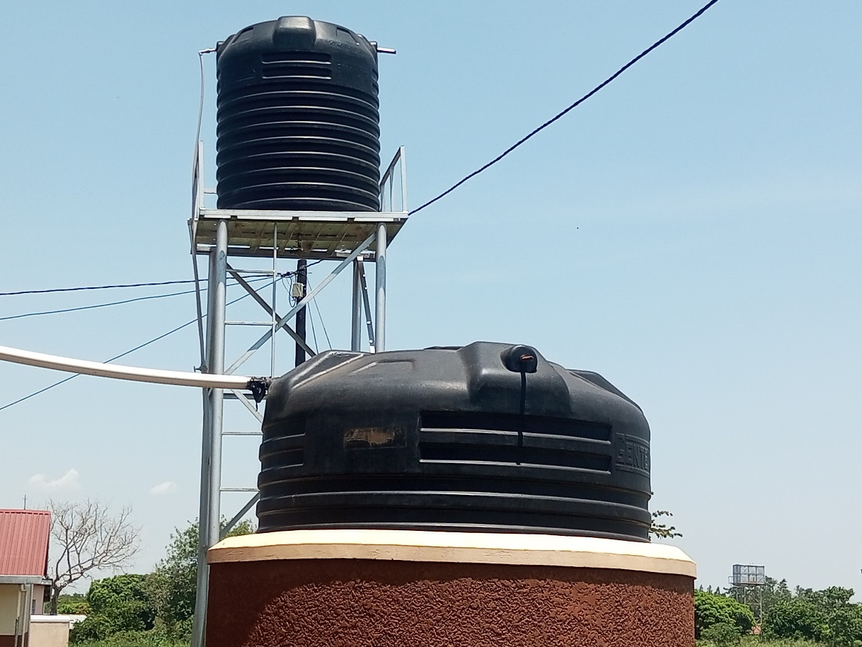

Water Tank in
Adeknino Seed
Secondary School

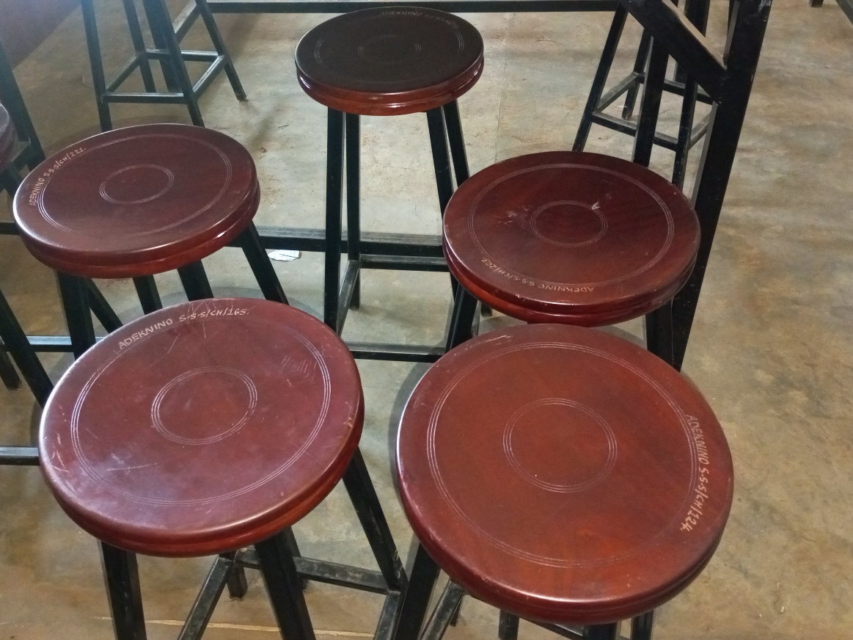

Laboratory Stools

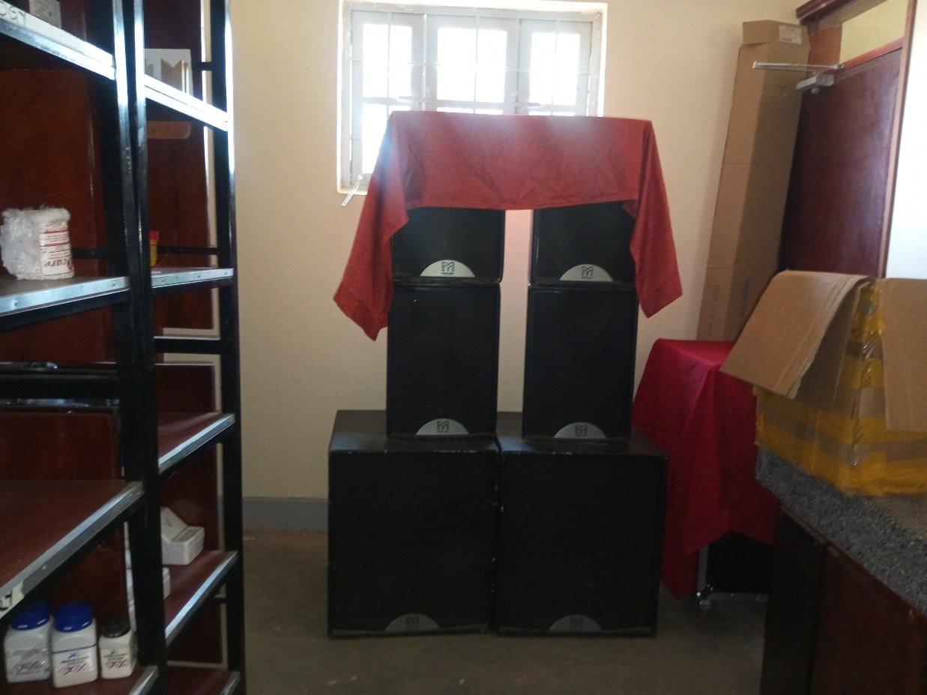

Public Address
System

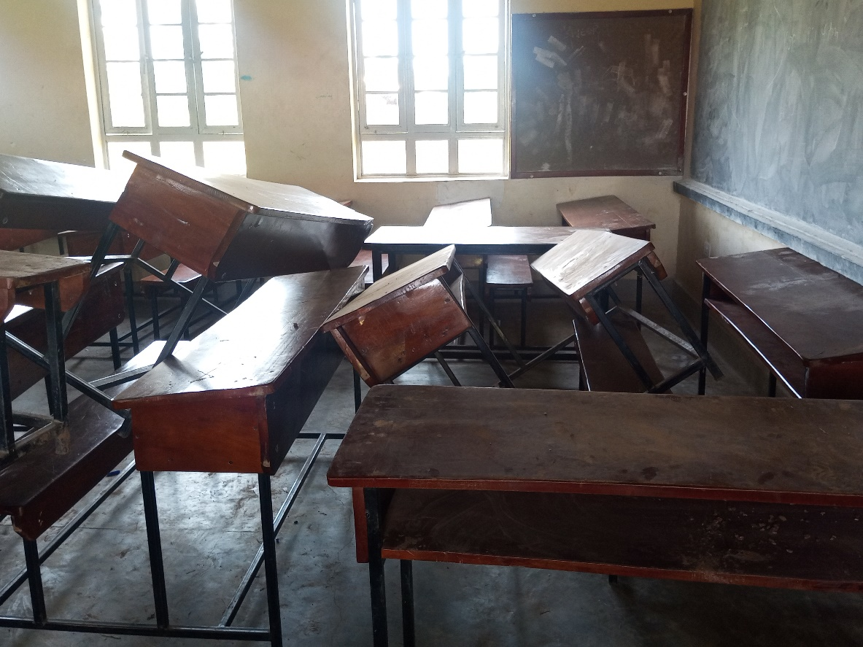

School Desks

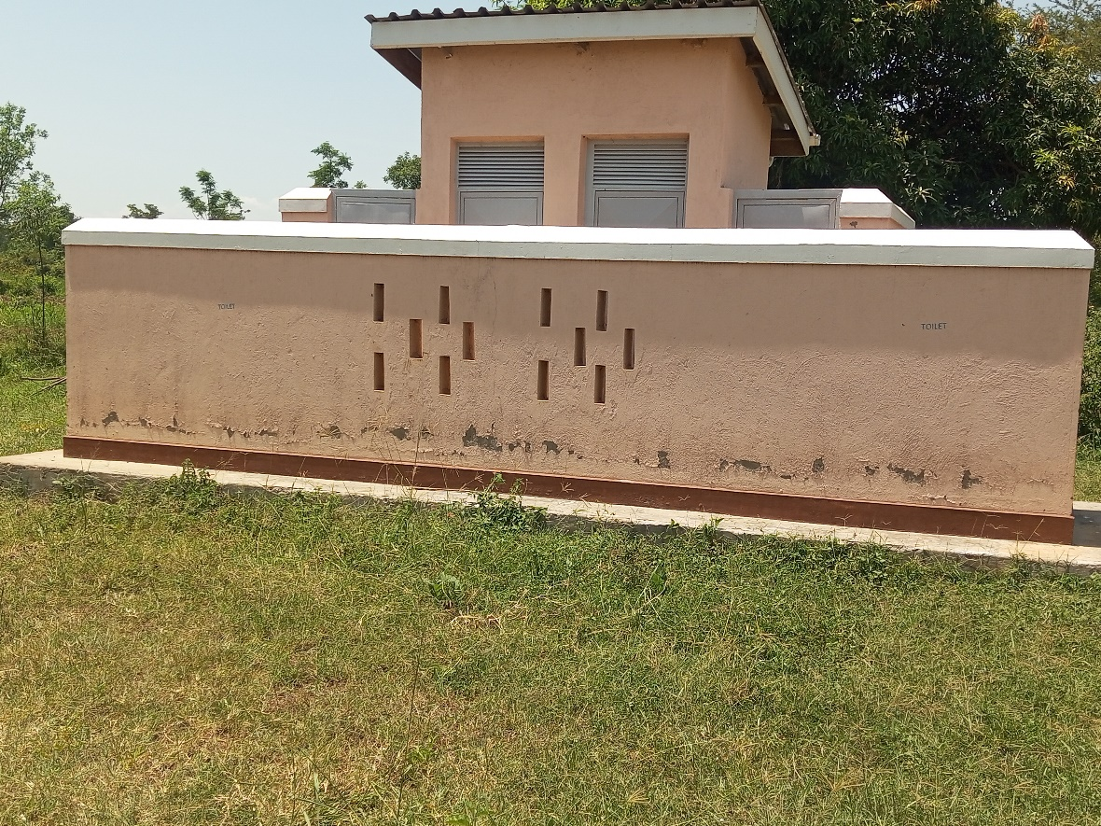

Pit Latrine

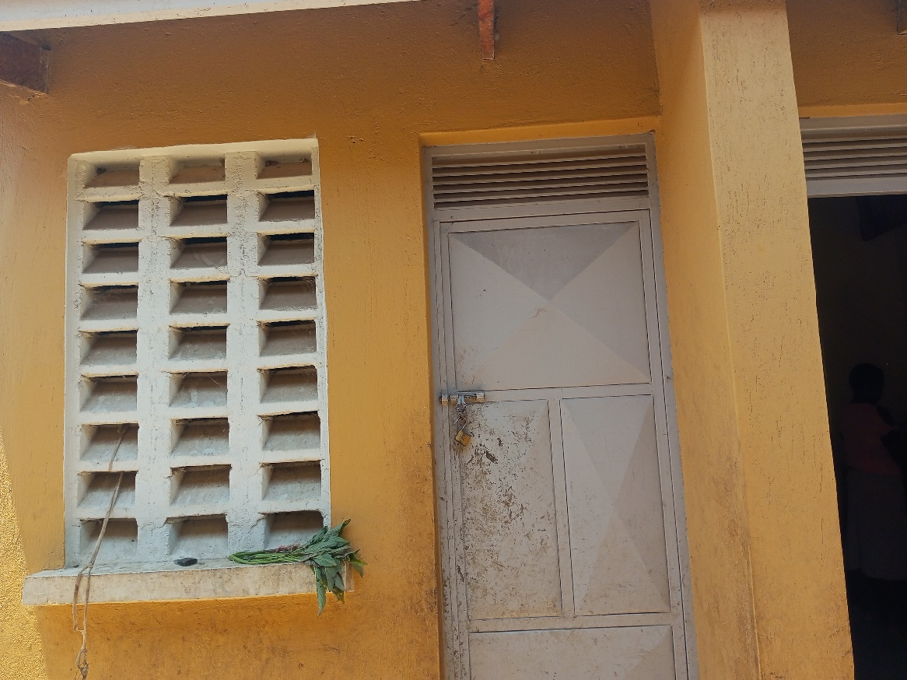

Staff Kitchen

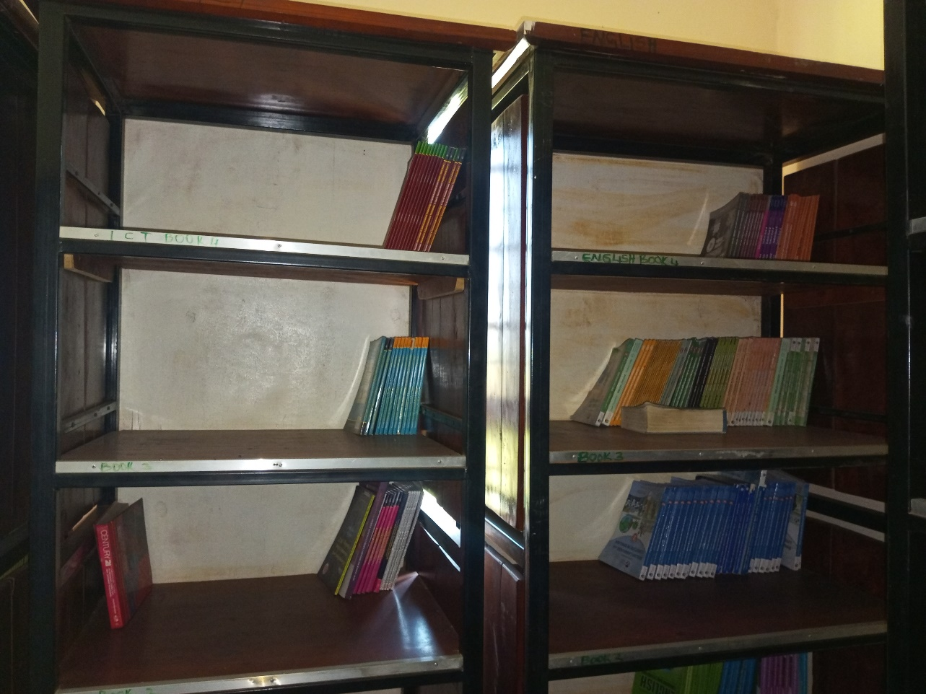

Sample of
Book shelves

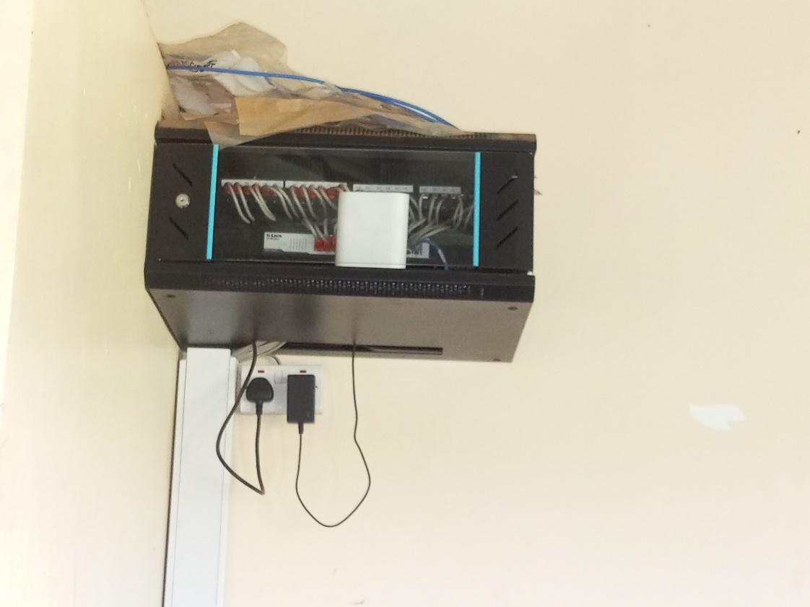

Server

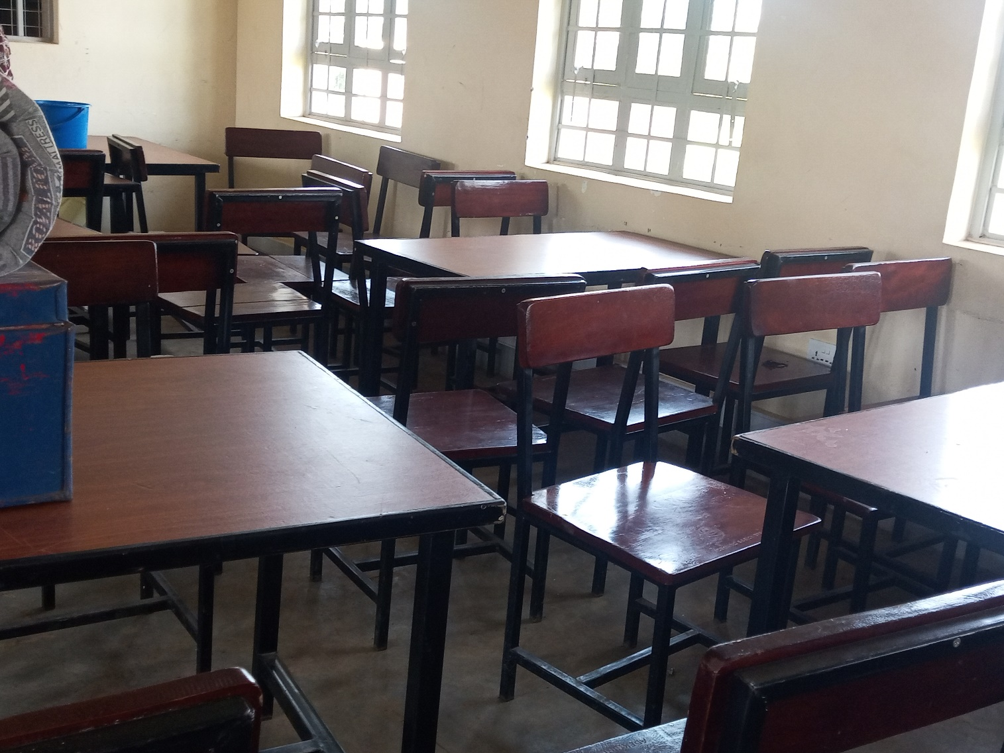

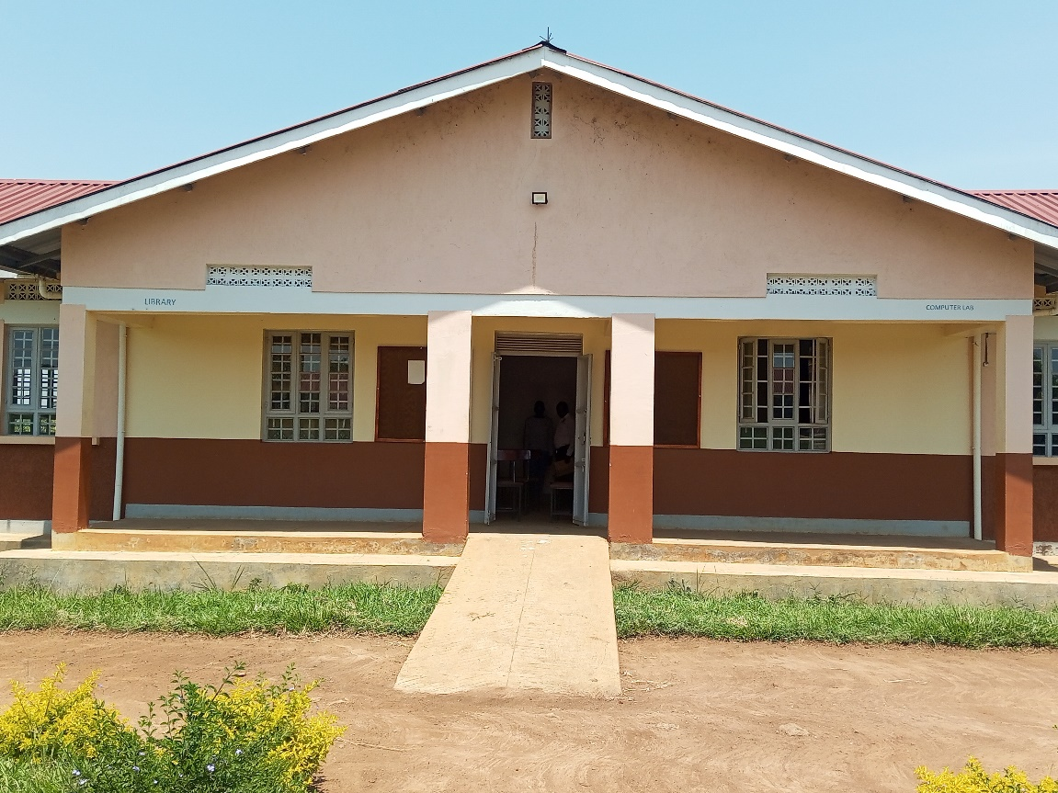

Adeknino Seed Sec. Sch.
Administration
and
Library Block

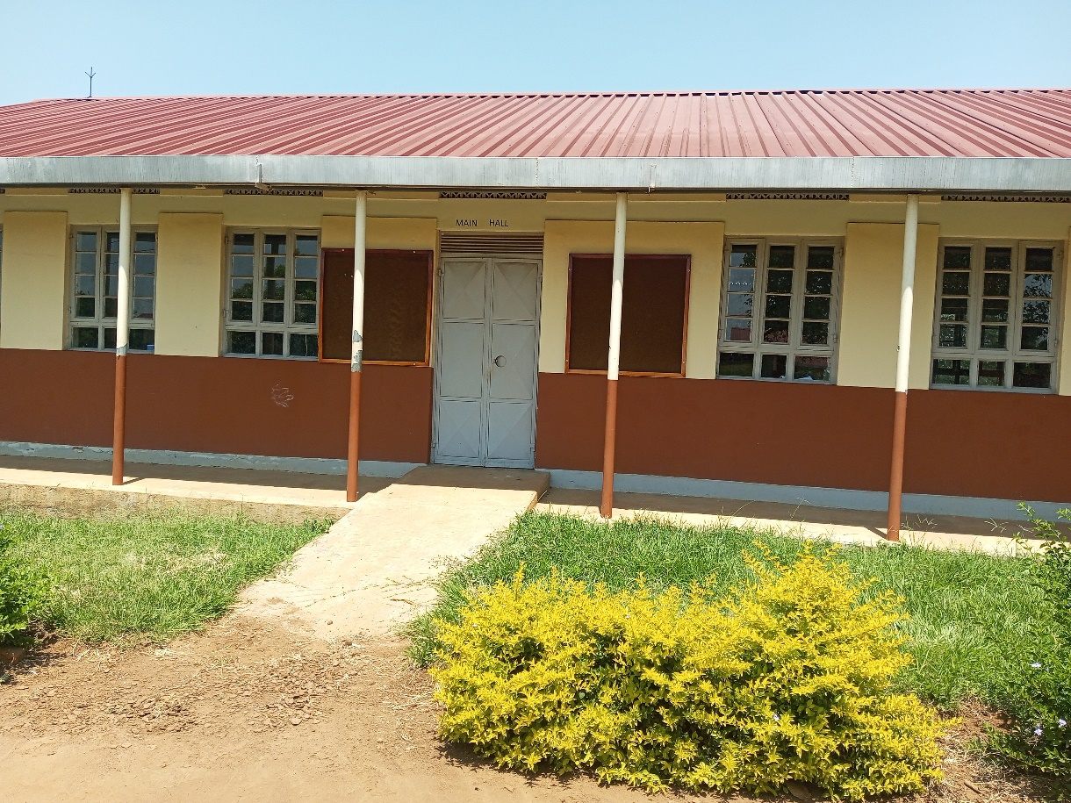

Main Hall

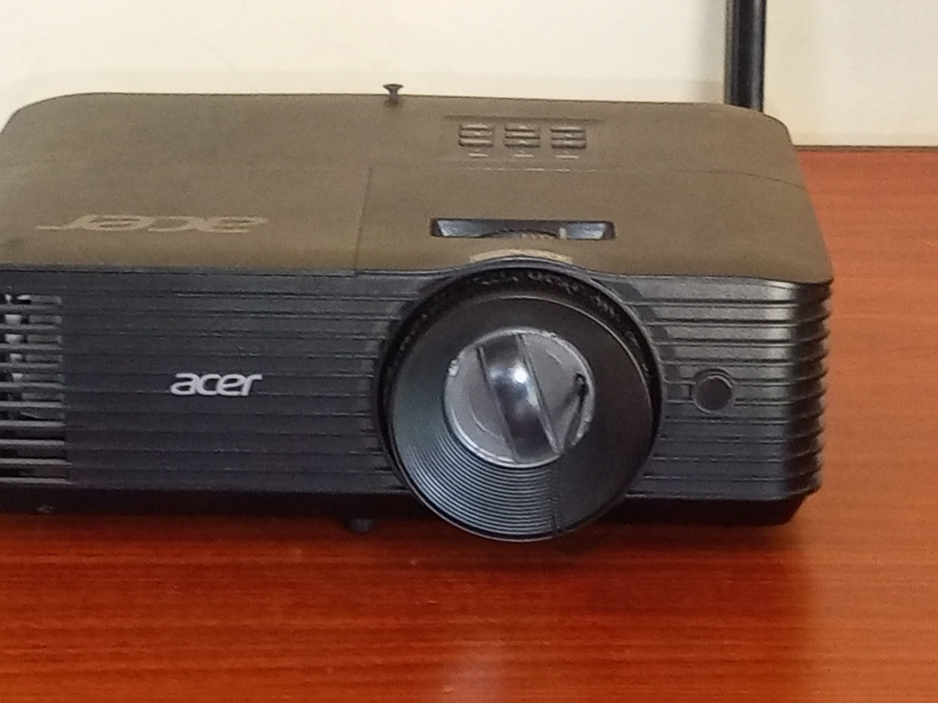

Projector

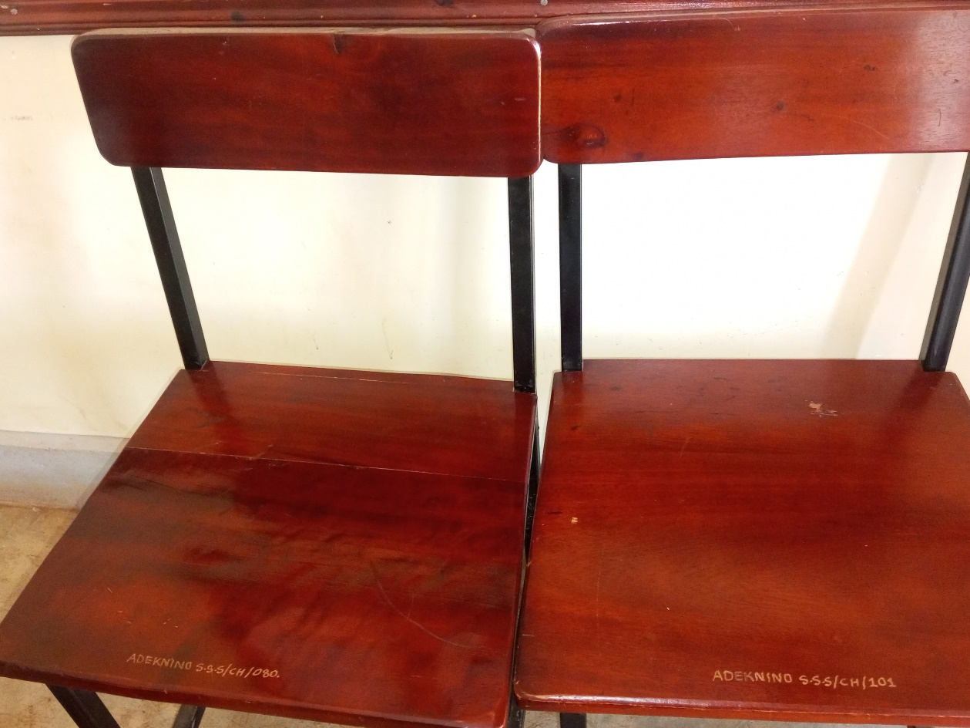

Office Chairs

